Title of Your Paper (Arial 14pt Bold)
First Author^{1 *}, Second Author² and Last Author² (Full name, Arial 12pt)
¹Department, Institution, Town, State/Country (Arial 11pt)
²Department, Institution, Town, State/Country (Arial 11pt)
*Corresponding author’s e-mail: author@abc.kyutech.ac.jp (Arial 11pt)
Keywords: List the keywords covered in your abstract (Maximum 6, Arial 11pt)

This one-page abstract template explains how to prepare your abstract for SAES2020. The authors must use the template given for the abstract to be accepted. Please make the page settings of your word processor to A4 format (21 x 29.7 cm or 8 x 11 inches); with the margins: bottom 1.5 cm (0.59 in) and top 2.5 cm (0.98 in), right/left margins must be 2 cm (0.78 in). Please use Arial 11 for main text, justified and single spacing paragraph for abstract format. Your abstract needs to contain the following points. The abstract is limited to a single page including figures and references.
Introduction: Briefly describe the Background and Motivations of your work. Cite references using footnotes.

Approach: Clearly state what is the approach of your research and describe your major achievements.

Results and Discussion: Present results and discussions to support your proposed approach. Illustrate your approach and results by referring to Figures (Fig. 1, Fig. 2). Note that authors need to clearly describe the significance of your work.

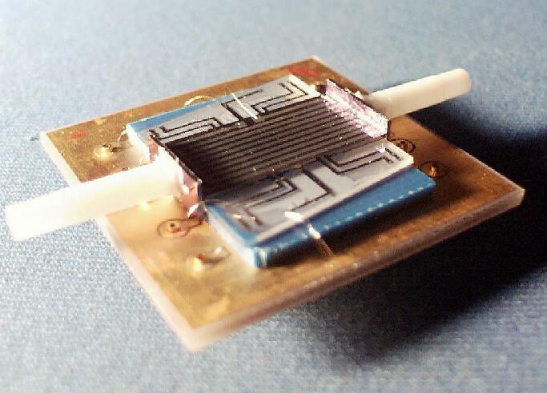
Fig. 1: Briefly describe the contents of figure, preferably self-explanatory.
Fig. 2: When using photos, make sure the resolution is sufficient.

